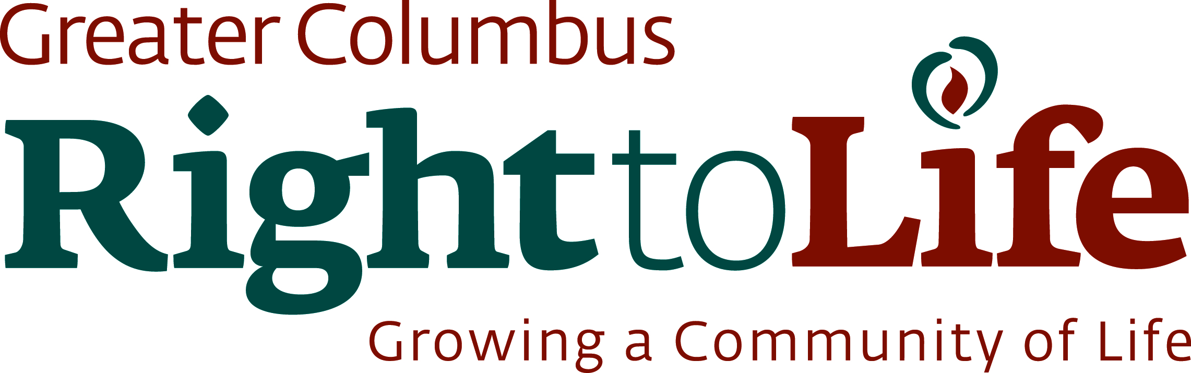

2016 Stewardship and Membership

The mission of Greater Columbus Right to Life is to promote a culture that protects innocent human life from conception until natural death. We serve the Greater Columbus Community through our efforts to educate people on pro-life issues and advocate for the pre-born, the aged and the infirm.

Please renew or begin your support today and encourage others to do so as well. Your contribution will support our pro-life initiatives and activities such as Sidewalk Counseling, 40 Days for Life, education, outreach, and grassroots efforts.

I would like to support the work of Greater Columbus Right to Life by:
$40 one-time donation $100 one-time donation A one-time donation in the amount of: _____________

I would like become a monthly donor to GCRTL
$10 each month $100 each month
$25 each month $_______ each month
$75 each month
Please contact me about other donor options and business sponsorship of GCRTL events
*Donations to GCRTL are tax-deductible to the extent of the law.

Name (please print)

Address

City, State, ZIP

Phone E-mail

Check Enclosed Please charge my credit card

Name as it appears on card

Card # ___________________________________________________ Sec #: _______ Exp. date

Signature:_________________________________________________________________________________________

I would like to volunteer. Please contact me about the following program(s):

40 Days for Life Prayer Partner
Office help Mailing preparation
Sidewalk Counseling Becoming a coordinator at my church
Annual Banquet Event Support

It is not necessary to donate to GCRTL to continue your membership. Membership is open to anyone with a heart for life by virtue of asking to receive information and mailings from us and upholding our statement of peace and belief.

Mail to: Greater Columbus Right to Life, 665 E Dublin Granville Road, Suite 115; Columbus, Ohio 43229

